|  |  |  |  |  |  |  |  |  |  |  |  |  |  |  |  |  |  |  |
| --- | --- | --- | --- | --- | --- | --- | --- | --- | --- | --- | --- | --- | --- | --- | --- | --- | --- | --- |
| panachee-commerce website for gifts | | | | | | | | | | | | | | | | | | |
|  | | | | | | | | | | | | | | | | | | |
|  | P |  | Prerna Dutta |  | S |  | Satyam Singh |  | N |  | Noni Bai | | |  |  | GR | 6 |
|  | | | | | | | | | | | | | | | | | | |
| vision | | | | | | | | | | | |  |  | | | | | |
| CLASSIFICATION OF TASKS | | | | | |
| The objective is to design and develop a functional ecommerce website that is capable of displaying searched data items that can be stored dynamically by the admin. The customers have their exclusive carts wherein they can store and purchase their own items without interference by other customers. | | | | | | | | | | | |  | * FRONT END DESIGNING * BACK END DATABASE * INTEGRATION AND TESTING  MAIN MODULES IDENTIFIED  * ANALYSIS * WEBSITE PAGES AND LINKING * CUSTOMER ACCOUNT * ADMIN PANEL * SEARCH AND FILTER MECHANISMS * DATABASE NORMALISATION, STORAGE AND RETRIEVAL * CART AND CHECKOUT SYSTEM * PAYPAL INTEGRATION  MODULES WITH RISK > 50% (AS ESTIMATED BY RISK ANALYSIS)  * SEARCH AND FILTER MECHANISMS * CHECKOUT SYSTEM | | | | | |
| WORK DIVISION ANALYSIS | | | | | | | | | | | |
|  | | | | | | | | | | | |
| |  |  | | --- | --- | | **Contributor** | **WORK\*** | | **Noni Bai** | **Linking pages and integration** | | **Prerna Dutta** | **Front end designing** | | **Satyam Singh** | **Back end Designing** |   *subject to minor alterations over time | | | | | | | | | | | |
|  | | | | | | | | | | | |  |  | | | | | |
|  | | | | | | | | | | | |  |  | | | | | |
|  | | | | | | | | | | | |  |  | | | | | |

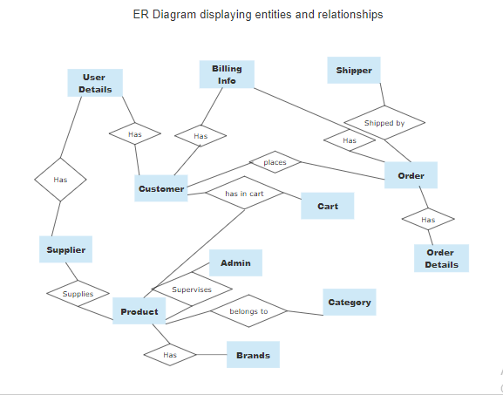

Note: Due to complexity involved in the ER diagram, the ER model has been broken into two parts:

The first part (shown above) displays the **Entity sets along with the relationships that they bear with other Entity sets**.

The second part (shown subsequently) shows **the individual attributes of the entity sets.**

**The various Entity sets along with their attributes are as follows:**

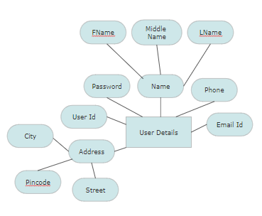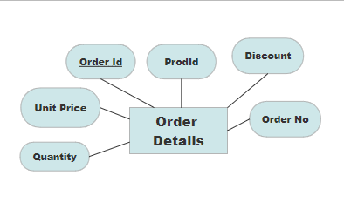

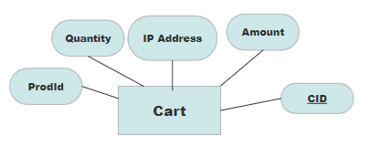

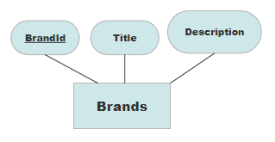

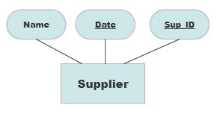

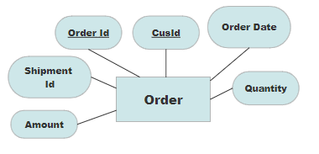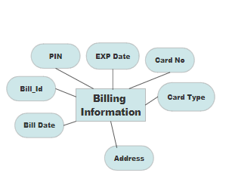

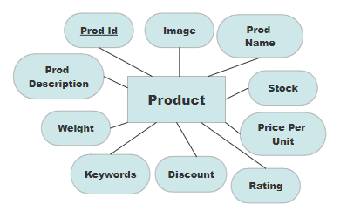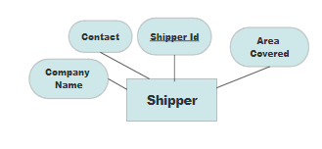

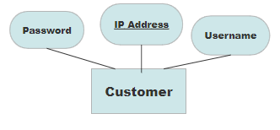

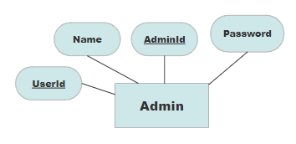

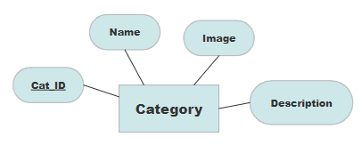

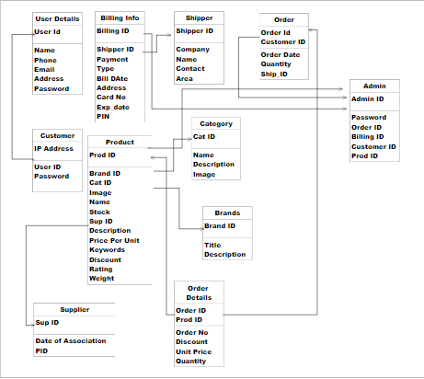

**Tables required in the database (obtained after normalization upto 3NF)**

**Note: This table shows how the foreign keys are linked to the primary keys of other tables thereby joining them together. The primary key holds unique values and is specified in the first column below the table names.**

LOGIN

REGISTER

CONTACTS

ABOUT US

HOME

REGISTER

LOGIN

C

H

E

*The one stop solution for personalised gifts…*



P

H

E

C

A

N

A

*The one stop solution for personalised gifts…*

### layout of THE WELCOME page

### layout of THE home page

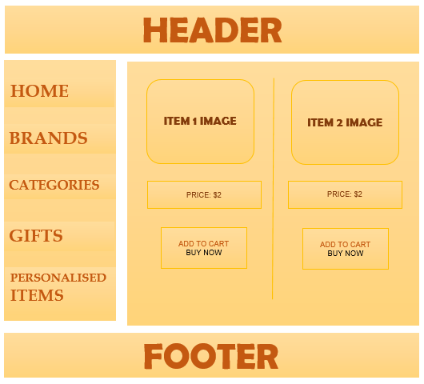

PLANNING:

The project has been divided into a number of sub-tasks based on the various components that are expected to function in the website. The tasks have been divided as follows:

|  |  |
| --- | --- |
| **TASK NO** | **DESCRIPTION** |
| ***1*** | ***Analysis*** |
| ***2*** | ***Homepage design*** |
| ***3*** | ***Login page*** |
| ***4*** | ***Customer account*** |
| ***5*** | ***Creation of Database*** |
| ***6*** | ***Registration*** |
| ***7*** | ***Normalisation of database*** |
| ***8*** | ***Collection of relevant images*** |
| ***9*** | ***Database Integration*** |
| ***10*** | ***Retrieval of Database*** |
| ***11*** | ***Review and Analysis*** |
| ***12*** | ***Customisations*** |
| ***13*** | ***Search and Filter Mechanisms*** |
| ***14*** | ***Purchase History display*** |
| ***15*** | ***Integration*** |
| ***16*** | ***Cart/Wish list and checkout*** |
| ***17*** | ***PayPal Integration*** |
| ***18*** | ***Form Display*** |
| ***19*** | ***Quality Improvement*** |
| ***20*** | ***Testing*** |

Task 1 has been successfully accomplished and the other modules were designed as an outcome of the analysis phase. The requirements were understood and listed and the different sections have been analyzed. The roles and activities to be performed by the team members have also been listed along with the estimated sequence and time slots of completion.

TIME ESTIMATION USING GANNTT CHART:

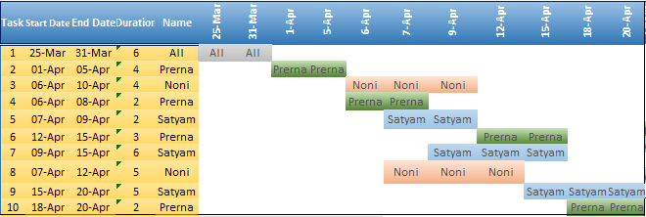

|  |  |  |  |  |  |  |  |  |  |  |  |
| --- | --- | --- | --- | --- | --- | --- | --- | --- | --- | --- | --- |
| **Task** | **Start Date** | **End Date** | **Duration** | **Contributors** | **25-Apr** | **5-May** | **10-May** | **15-May** | **20-May** | **25-May** | **31-May** |
| **11** | **20-Apr** | **25-Apr** | **5** | **All** | All |  |  |  |  |  |  |
| **12** | **25-Apr** | **05-May** | **10** | **Satyam** | Satyam | Satyam |  |  |  |  |  |
| **13** | **25-Apr** | **10-May** | **15** | **Prerna** | Prerna | Prerna | Prerna |  |  |  |  |
| **14** | **25-Apr** | **05-May** | **10** | **Noni** | Noni | Noni |  |  |  |  |  |
| **15** | **05-May** | **10-May** | **5** | **All** |  | All | All |  |  |  |  |
| **16** | **10-May** | **15-May** | **5** | **Satyam** |  |  | Satyam | Satyam |  |  |  |
| **17** | **10-May** | **20-May** | **10** | **Prerna** |  |  | Prerna | Prerna | Prerna |  |  |
| **18** | **10-May** | **20-May** | **10** | **Noni** |  |  | Noni | Noni | Noni |  |  |
| **19** | **20-May** | **25-May** | **5** | **Satyam** |  |  |  |  | Satyam | Satyam |  |
| **20** | **25-May** | **31-May** | **6** | **All** |  |  |  |  |  | All | All |